A Brief Guide to Church Architecture in Lincolnshire
This brief architectural guide complements the other training materials that we have put together including a short architectural dictionary. These can be found here (Insert link). This guide gives a brief description some of the main features of the different styles of architecture that you may encounter across the diocese. The examples used are all Lincolnshire churches, but these all follow broad national themes, so the information contained in this guide is applicable almost anywhere in England.
The dates given for the changing styles of architecture shouldn’t be viewed as exact, as changes happen at different rates from place to place and new ideas and fashions from higher status buildings such as cathedrals take a while to filter down to local church level. However, the date ranges given will give you an idea of roughly how old certain features are and how your parish church may have evolved and grown over the centuries.
Anglo-Saxon c.600 – 1150
Any church mentioned in Domesday Book is likely to be of Anglo-Saxon origin although in 1086 it may have been timber, stone or both. Due to the date of this style most surviving Anglo-Saxon architecture in Lincolnshire is rather fragmentary due to later developments, enlargements or remodelling of the church building so it tends to survive in a tower or a section of walling.
Anglo-Saxon architecture is Romanesque in style; that is based on Roman architecture from centuries earlier which had a renaissance across Europe from the 7th century through to the 1200s. The style is broadly based on the Roman semi-circular arch which is used for windows openings, door openings and arches such as a tower arch. Romanesque is a style that is not easily defined and has many regional and local variations across Europe, but in the context of Lincolnshire we are looking at details such as long and short quoins, double belfry openings, herringbone pattern masonry and the reuse of Roman stone.
Rothwell St Mary Magdalene. A church of 11th century date with typical Anglo-Saxon features including double belfry openings with a mid-wall shaft (much restored) and corners of the tower constructed with side alternative quoining. That is larger blocks of stone laid in opposite directions. Note the corner of the original nave between the tower and the south aisle.

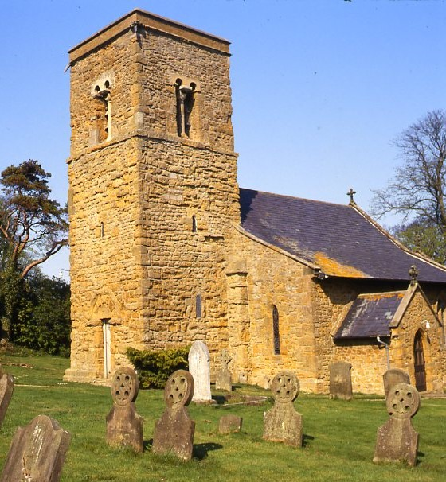
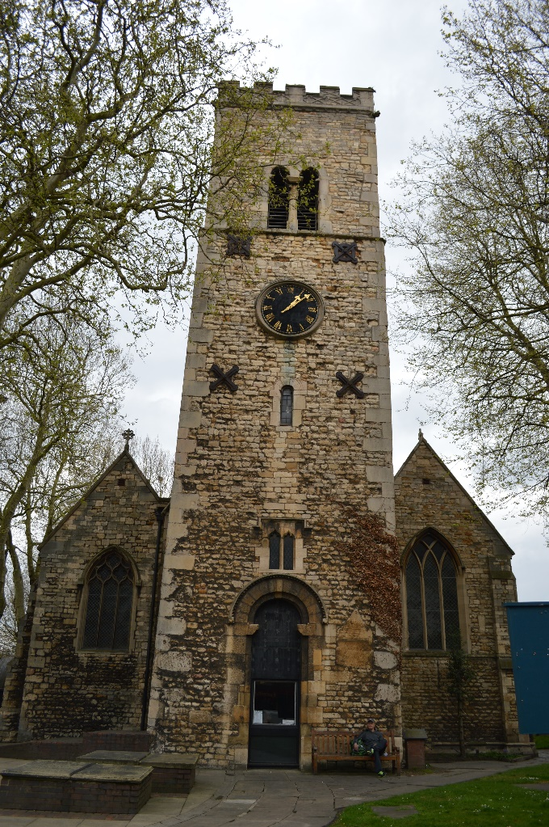
Lincoln St May le Wigford. Another Anglo-Saxon tower with side alternate quoining, double belfry openings with a central shaft and built from reused Roman stone including a Roman tombstone with a later 11th century medieval inscription on it.

English Romanesque / Norman c.1050 – 1170s
The Norman Conquest brought with it large-scale building projects including castles, abbeys, monasteries and parish churches, particularly from the 1070’s onwards. This was as a means of the Normans demonstrating their wealth and power over the land and consolidating their hold on the new kingdom.
Norman Romanesque architecture is still based on semi-circle for arches, doors and windows, but this type of Romanesque is heavier and often more accomplished in terms of its finish with neater stonework and finer mouldings. This architecture tends to start quite plain and austere, but towards the end of the period is characterised by a wealth of surface decoration such as chevrons, beak heads and interlaced arcading. In Lincolnshire parish churches the style is complicated by the fact that the influence of Anglo-Saxon architecture and Norman architecture can be found in the same building with a mixture of the two styles which is often referred to at Saxo-Norman.
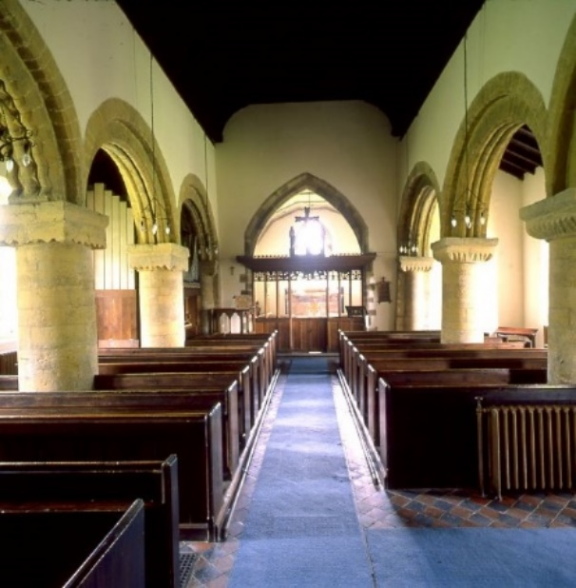
Left the mid -12th century interior aisle arcades of Rothwell St Mary Magdalene. Note the short circular columns support square capitals which in turn support the semi-circular Norman arches which have a surface decoration of chevrons
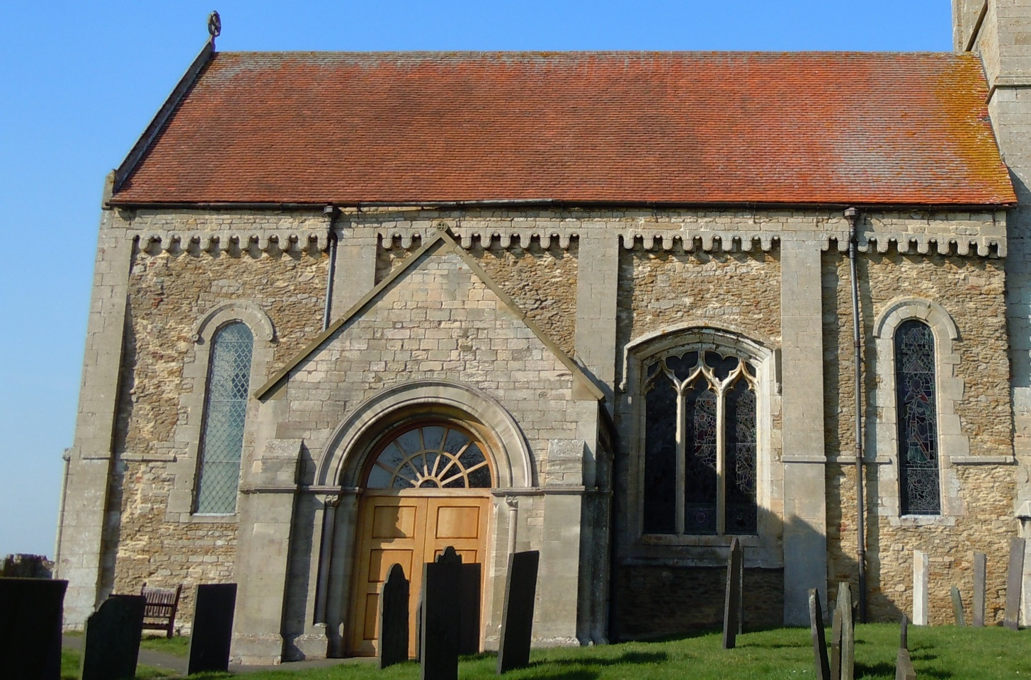
Above the south wall of the nave of Sempringham St Andrew showing the Norman exterior. The semi-circular lancet windows either end are of 1170s date as is the corbel table just below the roof eaves. The vertical sections dividing the wall up are known as pilasters and are an early form of buttress. The porch is 19th century

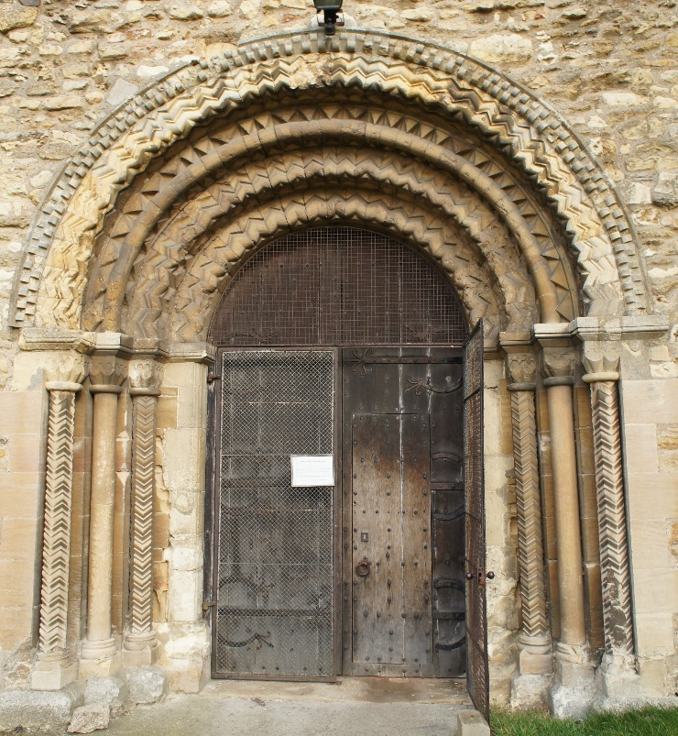
Left the late Norman south door of Stow St Mary showing by this time surface decoration was popular. In this example chevron is prolific but other motifs are included such as the billet moulding on the outer ring of the arch.

Transitional c.1175 - 1200
Developments in France in the 1140s led to the development of a new style typified by pointed arches which was a sharp contrast to what had gone before - a style we now call Gothic. It was first introduced in England in the 1170s in Canterbury cathedral, however at parish church level there seems to have been a reluctance to fully embrace the new order and we therefore have a period where the designs of the old are mixed with the new - a Gothic arch with chevron decoration for instance. We also get some distinctive closely dateable features called waterleaf capitals These are common on the eastern side of the country and can be found throughout Lincolnshire and are only used for a short period c. 1170-90.
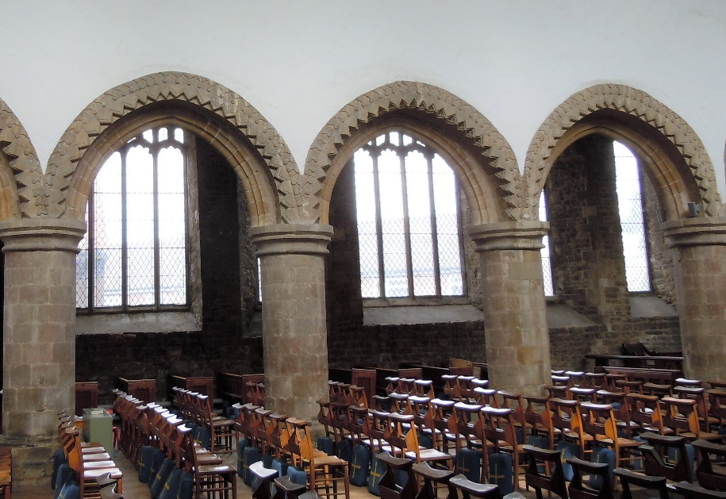
Left the Transitional north aisle arcade at Barton upon Humber St Mary, which is a combination of a Gothic pointed arch with late Norman decoration including chevrons.
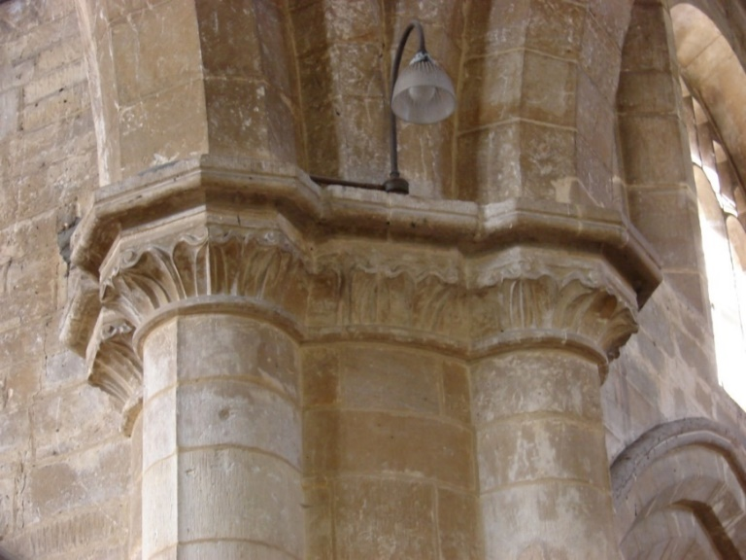
A typical Transitional detail of a waterleaf capital which is closely datable to the period 1170 -1190. This example is from Algarkirk St Peter and St Paul.

Early English c.1190 -1250
The Early English style as we call it now was the first of the new Gothic styles in England. The aim of Gothic was to make churches higher, as a way of glorifying God, become physically closer to heaven and to be seen from miles around. This was achieved by a major technological breakthrough – the pointed arch. This new arch design gave the ability to create a structure that was no longer dictated by the dimensional limitations of a semi-circle. Despite its name Early English Gothic derives from technological developments in the Paris basin in the 1140s. The first influential building to use this new style was Canterbury cathedral in the 1170s followed shortly after by the equally influential Lincoln cathedral in the early 1190s.
The style is characterised by sharply pointed arches, lancet windows, indulgent mouldings and surface decoration. It is a style that is used from the late 12th century through to around the 1250s. At parish level with this style we get cruciform plans e.g. Grimsby Minster, Old Clee and Bottesford; churches with west towers, for example Stamford St Mary and Gedney and we also get broach spires e.g. Sleaford, Frampton and one of the earliest in the country North Raucby St Peter.
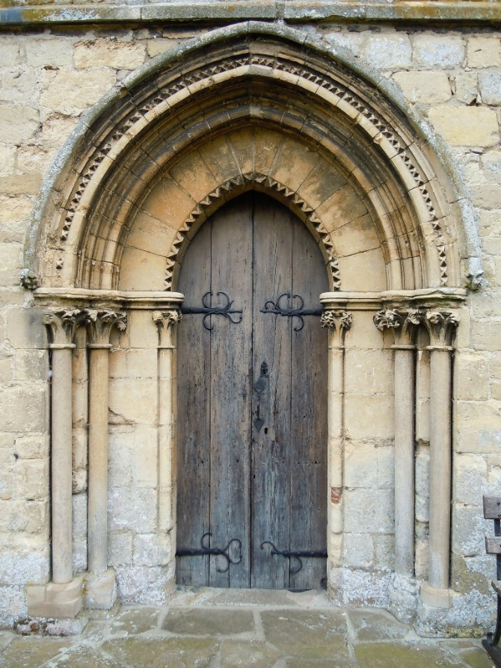
The Early English west door of Kirkstead St Leonard c.1230-40. This illustrates a number of elements of the Gothic style including the dogtooth decoration around the arch. These are small pyramids mouldings with notches cut out of them. The capitals of the small shafts either side of the door are called stiff-leaf capitals which are a form of a fleshy type leaf very popular at the time. Note the sharply pointed arch in contrast to the Romanesque period arch that preceded it.
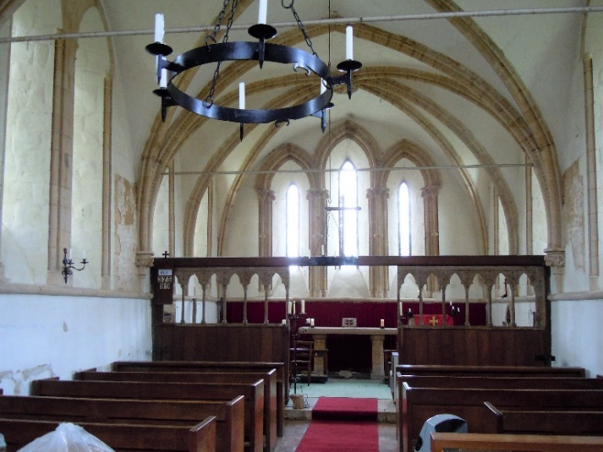
Left the interior of Kirkstead St Leonard showing the sharply pointed lancet windows of the Early English style. These can be usually be found as a group as seen here or singularly.
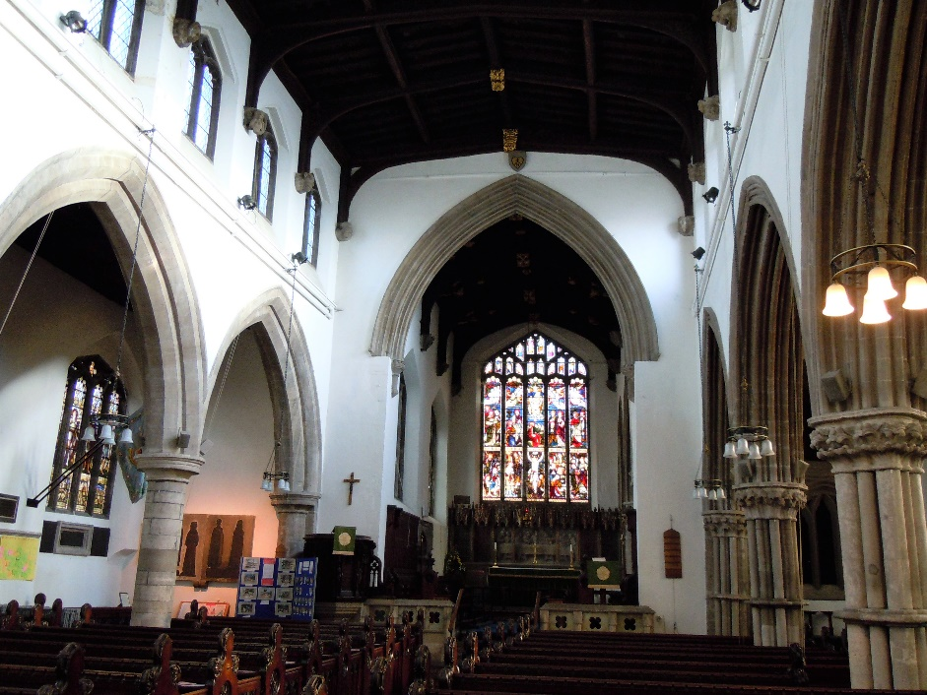
Stamford All Saints left, demonstrates the diversity of Early English architecture. To the right of the picture is the richly moulded south arcade with columns with multiple shafts, stiff-leaf capitals and deeply cut moulding to the arch all c. 1230. Opposite on the north arcade are double chamfered arches supported on tall slender circular columns and circular column capitals all a fraction later than the south arcade.

Decorated c.1240 – 1350
The next style is basically a continuation of the Early English Gothic but one that becomes more decorative as it develops hence the name. This style develops from the 1250s through to the 1350s. Decorated Gothic marks the beginning of an age of experimentation and creativity in building. The development of bar tracery in France in the 1240’s allowed for an elegant masonry embellishment to windows and created multiple compartments for stained glass.
The earliest form of Decorated (c.1240 – 90) is more geometrical in design using arrangements of circles and lines, and tends to have an ordered, repetitive feel to it. However, as the style evolves it becomes more naturalistic and flowing and far more complex. This is made possible with the ogee arch or a reverse ‘S’ which can be found throughout the tracery of this period. This period is ended with the arrival of the Black Death in 1349-50 which killed on average up to 50% of Europe’s population.
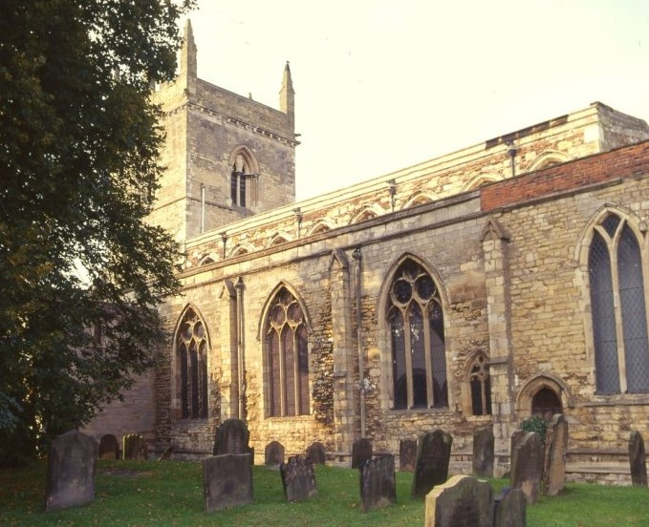
Left, Heckington St Andrew and perfect example of a late Decorated period church with curvilinear tracery and extensive use of the reverse ‘S’ or ogee arch in the east window tracery c. 1330.
The geometric Decorated windows in the south aisle of Barton upon Humber St Mary. The three windows to the left and centre of the picture have circular tracery above and arrangement of three pointed lancet windows all of which are within a larger arched opening. These date to c. 1270s. The window to the right of the picture has what is called ‘Y’ tracery and dates to about c. 1300.
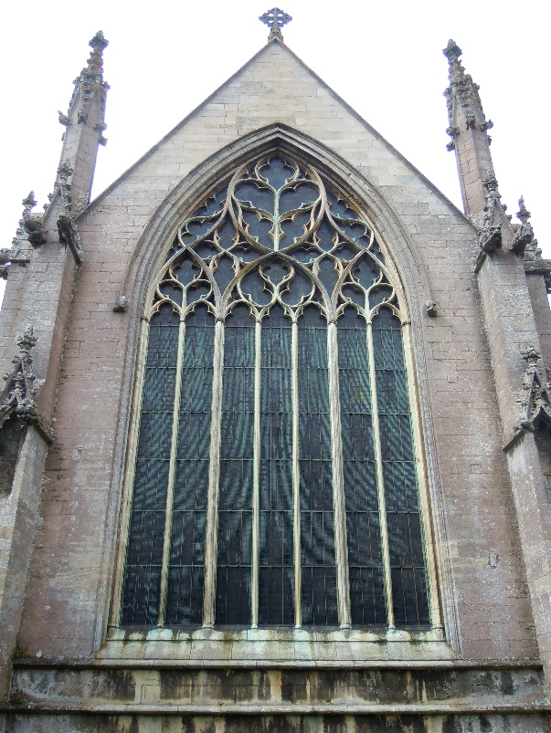
The interior of Heckington St Andrew looking east towards the same window. The nave arcade arches are double chamfered and the columns are made up of four shafts forming a clover leaf type shape in plan – a typical Decorated period detail.
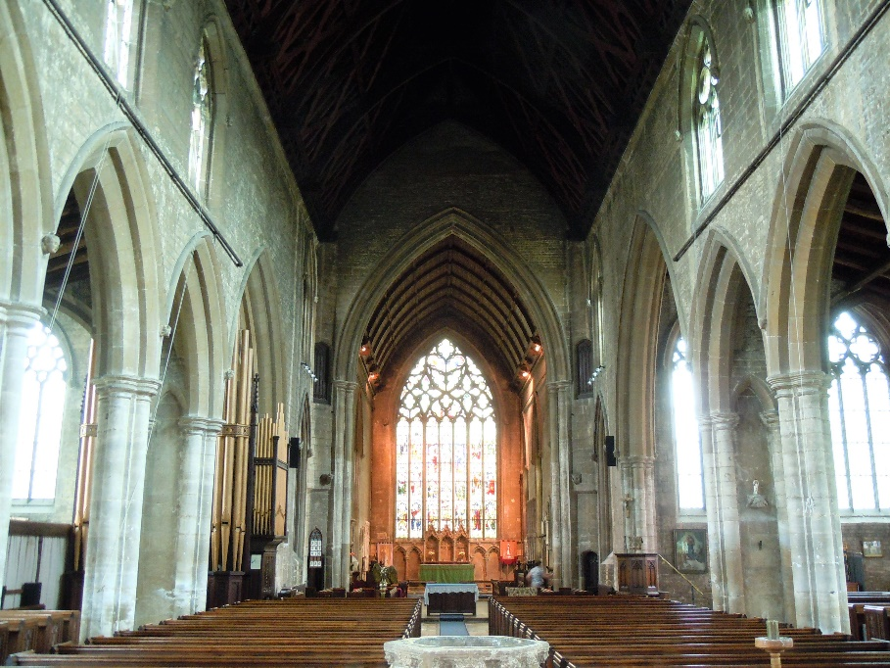
Perpendicular (Perp.) c.1350 – 1540s
Originating in London, particularly in royal buildings, the Perpendicular style is based on straight lines where the emphasis is on the vertical - or perpendicular - over the horizontal which gives the style its name. It is a style unique to England and unlike previous styles is not influenced by France. Key features of Perpendicular are large windows with vertical elements known as mullions. With these windows builders strove to create almost transparent structures. Arches in this period become flatter than those that preceded them and are known as four-centred arches. At a parish level this is commonly the period where clerestories, chapels and porches were added, new tops added to towers and in some cases churches may have been partially or completely rebuilt.
Two fine examples of the Perpendicular style are Tattershall Holy Trinity begun in 1469 and completed in 1482 and Louth St James started in 1430, the tower was completed in 1445 and the spire was finished in 1515. Other examples can be found in the medieval communities along the coast or coastal marshes: Boston St Botolph tower or Stump built between 1420s and 1520s, Marshchapel St Mary, Grainthorpe St Clement part Decorated and part Perpendicular, Croft All Saints and Burgh le Marsh to name but a few.
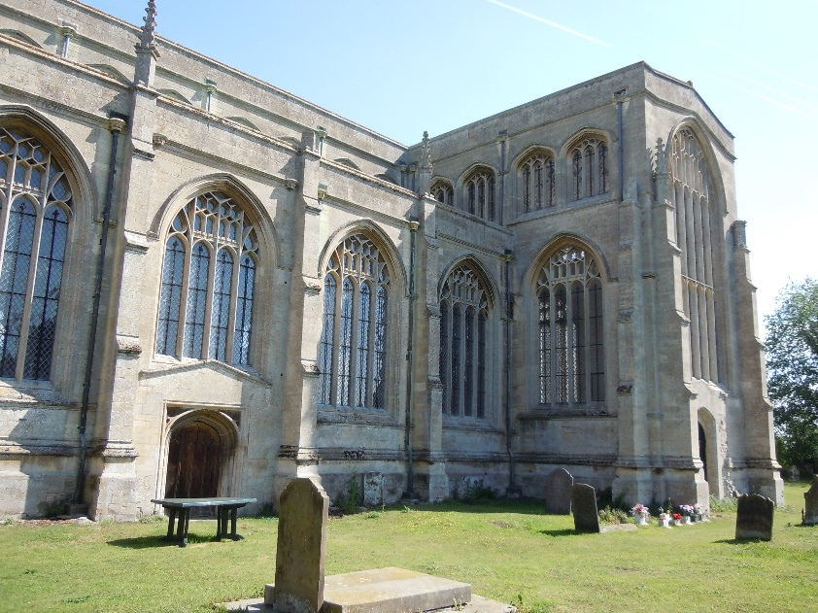
Tattershall Holy Trinity illustrates the Perpendicular style with walls filled with large windows which have flattened arches and a strong vertical or ‘perpendicular’ emphasis. Buttresses now project further away from the building but are narrower than in previous periods.
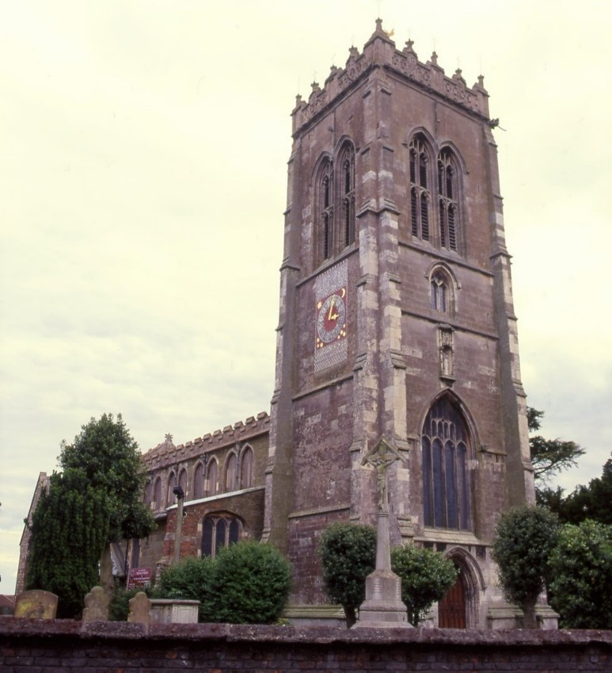
Burgh le Marsh St Peter and St Paul a typical Perpendicular church with tower on the east coast of Lincolnshire. Note the large west window and the large double belfry openings all typical of the period.
Georgian 1714 - 1830
In the years after the Reformation we then have the English Civil War (1642 – 1651) after which there is little in the way of church building or rebuilding going on. It is not until the Georgian Age (1714 – 1830) when we see church building again, but this time in a more classical form of architecture drawing inspiration from the styles of ancient Rome and Greece. Early examples of the style include Stainfield St Andrew (1711) and Langton by Spilsby St Peter and St Paul (c. 1720-30) with a complete Georgian interior. Later examples include Gainsborough All Saints (c. 1736 – 1744) and Cherry Willingham St Peter and St Paul (c.1753).
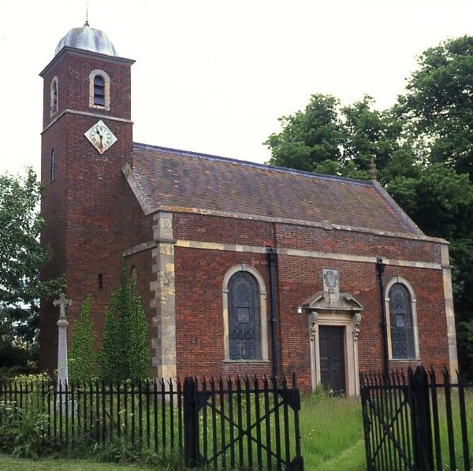
Left Stainfield St Andrew an early Georgian church built from brick with dressed stone details.
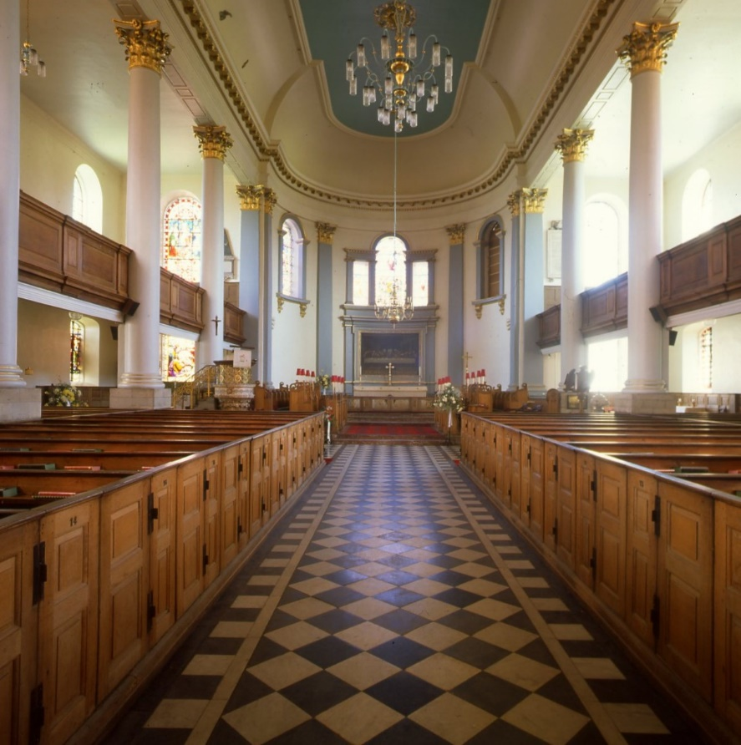
The classically inspired interior of Gainsborough All Saints built 1736 – 1744 by the architect Francis Smith. Note the apsidal (semi-circular) east end and Venetian window – a popular arrangement of a large central window flanked by two smaller ones which are typical details of the period. The columns have Corinthian capitals a design which originated in ancient Greece
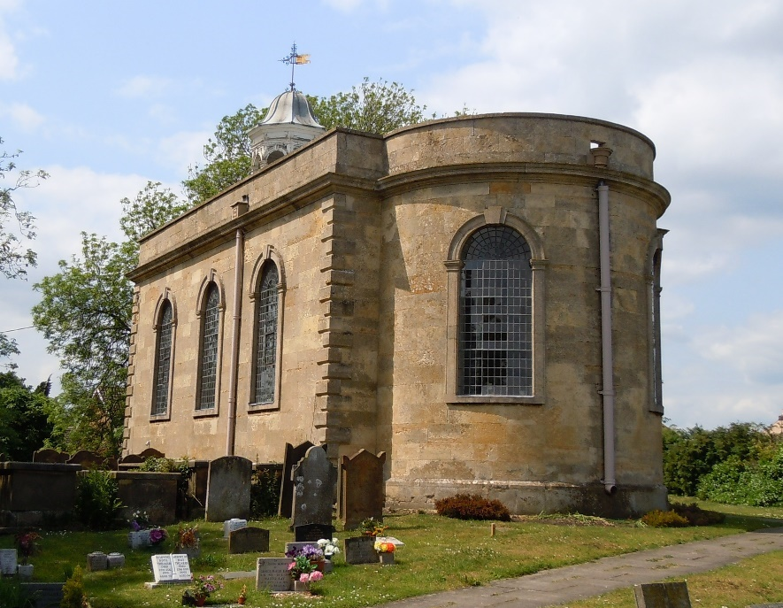
Cherry Willingham St Peter and St Paul c. 1753. Here the design also includes an apsidal east end and semi-circular arched windows as seen in the previous examples.

Victorian Gothic Revival c.1830 – 1900
The 19th century saw an influx in the reuse of medieval styles and motives, particularly those belonging to the Early English and more so the Decorated Gothic period. It is important not to confuse features designed during this period with genuine medieval architecture. Although this was based on archaeological and historical research, Gothic revival architects also drew heavily on their own imaginations to create buildings and interiors that were an idealised vision of pre-reformation ecclesiastical buildings. Gothic revival elements may tend to be slightly pastiche and more fantastical, and stonework will appear less worn than true Gothic features. Interior painted decoration in green, red, cream and black that appears stencilled on, is more often than not Gothic Revival and not medieval. Victorian stained glass may have a date incorporated as part of the design. Well-known national architects working in Lincolnshire included George Gilbert Scott, S. S. Toulon, and C. H. Fowler. Local architects include the prolific James Fowler of Louth and Kirk and Parry from Sleaford.
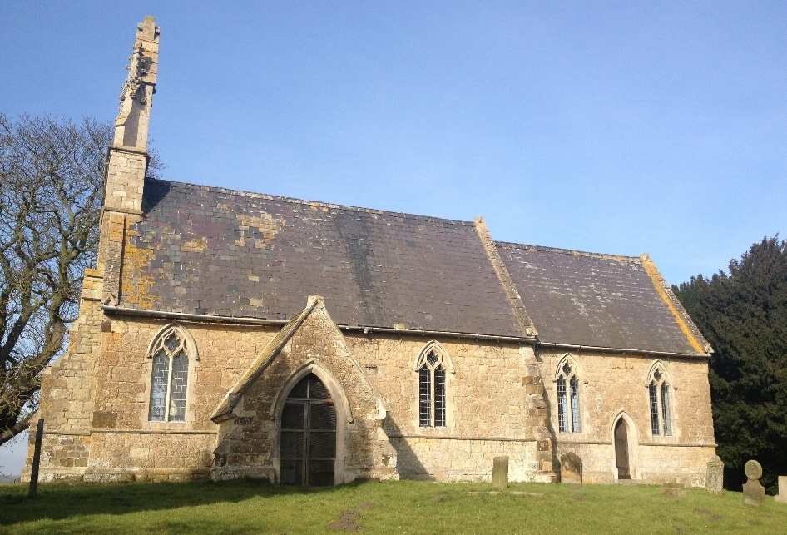
The rebuilt church of East Torrington St Michael 1848-50, by the architect S. S. Toulon. The church is a similar design to many across the county which conform to what the architects of the time thought was the ideal small parish church. That is a building with a nave, slightly smaller chancel, south porch and a west bellcote. The windows are in the style of the medieval Decorated period.
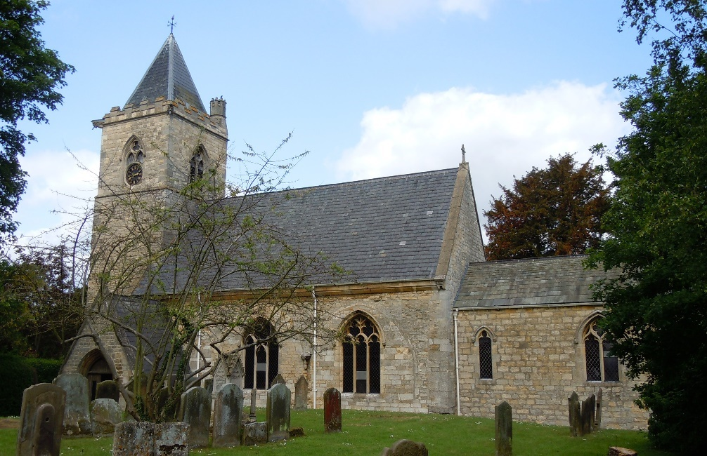
As well as rebuilding churches such as with East Torrington above they were also prolific restoring them. At Reepham St Peter and Paul left the chancel was rebuilt in 1836 and then in 1862 a completely new roof was added over the nave, an additional stage and pyramid roof added to the tower, a new south porch constructed. New windows in the medieval Perpendicular style were also installed. This work was undertaken by the architect Michael Drury.

